Lab of cloud watch

# EC2 Memory Disk Monitoring
Monitor EC2 Memory and Disk Utilisation using CloudWatch | AWS EC2 Monitoring with Cloudwatch | Monitor Memory and Disk Utilisation using CloudWatch | AWS CloudWatch Demo

## Steps:

Step 1: Create an AWS EC2 IAM Role and add CloudWatch and SSM Full Access. - Role Name: EC2-CloudWatch-Role. \
Step 2: Create a Parameter in Systems Manger with the name "/alarm/AWS-CWAgentLinConfig" and store the value. \
Step 3: Create an EC2 Instance, Attach the role created in Step 1 and Add the commands in the Userdata Section.

## Commands that needs to be added in Userdata Section:
bash
#!/bin/bash
cd /opt
wget https://s3.amazonaws.com/amazoncloudwatch-agent/linux/amd64/latest/AmazonCloudWatchAgent.zip
unzip AmazonCloudWatchAgent.zip
sudo ./install.sh
sudo /opt/aws/amazon-cloudwatch-agent/bin/amazon-cloudwatch-agent-ctl -a fetch-config -m ec2 -c ssm:/alarm/AWS-CWAgentLinConfig -s

## Check if EC2 Instance has CWAgent Installed or not:
bash
sudo /opt/aws/amazon-cloudwatch-agent/bin/amazon-cloudwatch-agent-ctl -m ec2 -a status

## Value for the SSM Parameter (/alarm/AWS-CWAgentLinConfig):
====
{
"metrics": {
"append_dimensions": {
"InstanceId": "${aws:InstanceId}"
},
"metrics_collected": {

"mem": {
"measurement": [
"mem_used_percent",
"mem_available"
],
"metrics_collection_interval": 60
},

"swap": {
"measurement": [
"swap_used_percent"
],
"metrics_collection_interval": 60
},

"disk": {
"measurement": [
"used_percent",
"inodes_free"
],
"metrics_collection_interval": 60,
"resources": [
"*"
],
"ignore_file_system_types": [
"sysfs",
"devtmpfs",
"proc",
"tmpfs"
]
}

}
}
}

===

## Reference/Additional Reading:
1. https://docs.aws.amazon.com/AmazonCloudWatch/latest/monitoring/Install-CloudWatch-Agent-New-Instances-CloudFormation.html
2. https://docs.aws.amazon.com/AmazonCloudWatch/latest/monitoring/CloudWatch-Agent-Configuration-File-Details.html

============================================================================
- Create a IAM Role and apply the role while creating the instance

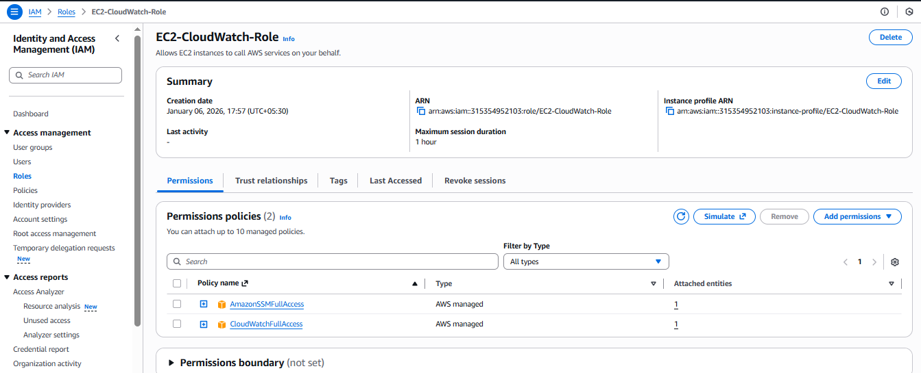

Create ap parameter using ssm manager service

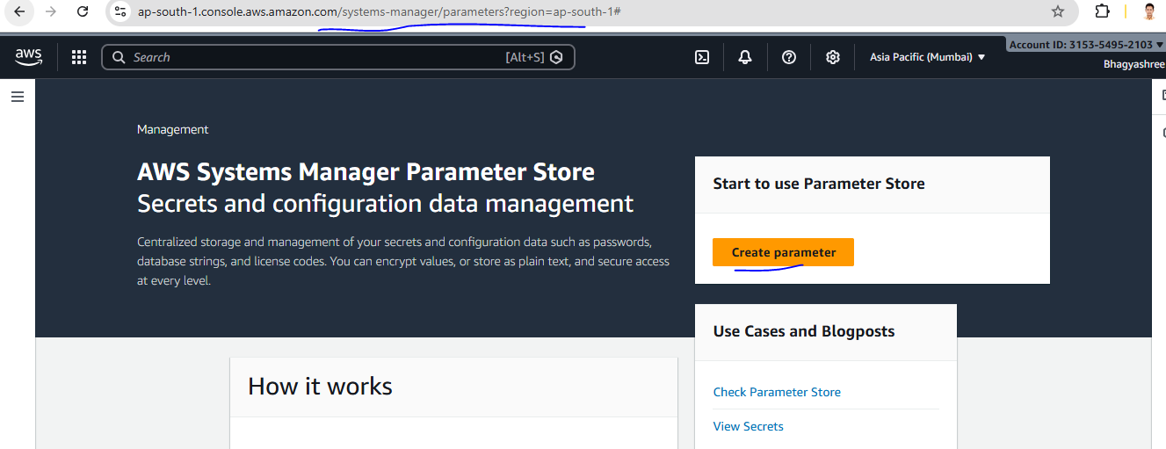
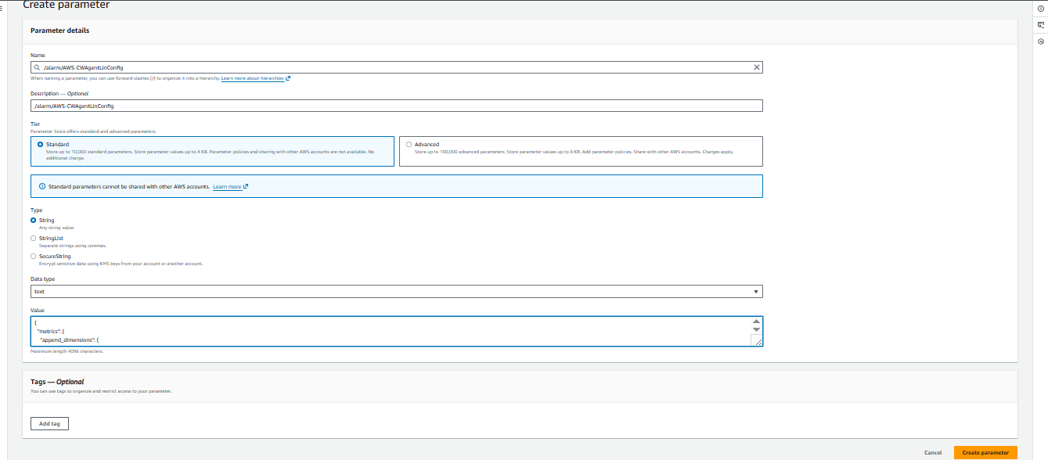

Parameter has been created with configuration (as mention json file above)
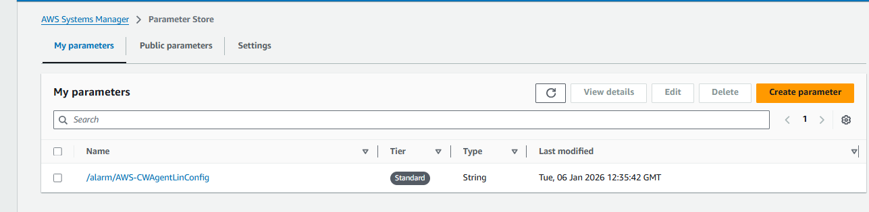
Instance has been created with the EC2-CloudWatch-Role and using user data section as mention above
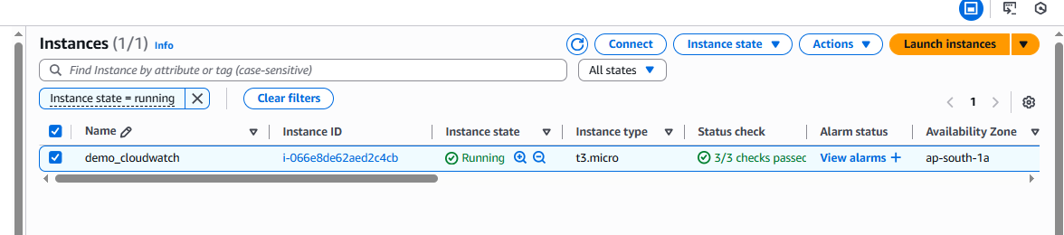
Create one ebs volume and attached this to the running instance
Then go to the cloudwatch service and select the metrics once select all metrices select please search the CWagent and open as shown below
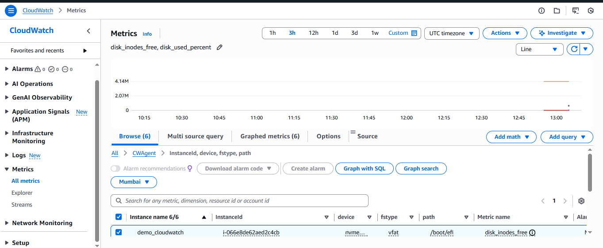
Once select all metrices please create a dashboard as mention below
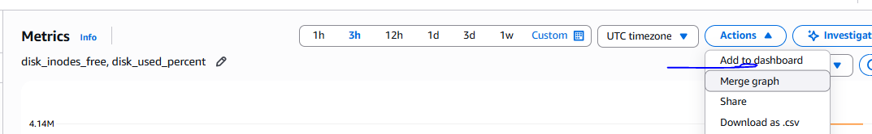

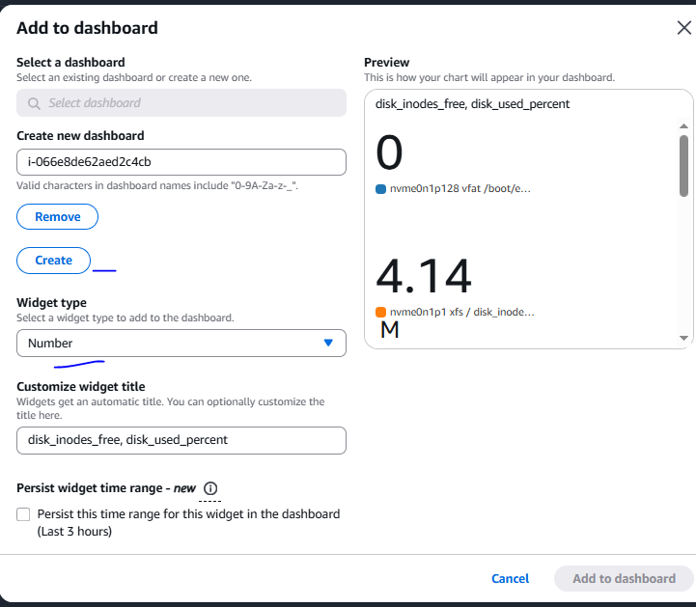
Dashboard has been created with number
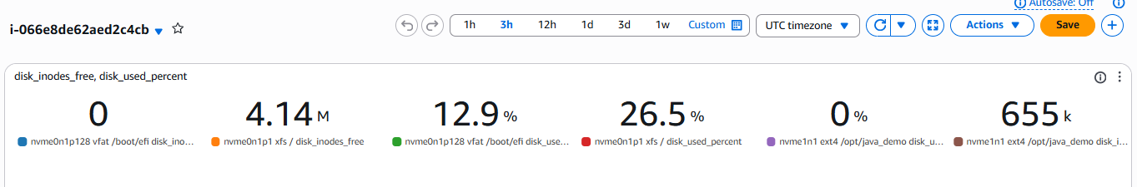

We can create alarm if root is cross 30%
Need to take a cursor on and click on alarm button
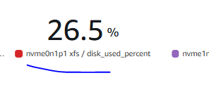\
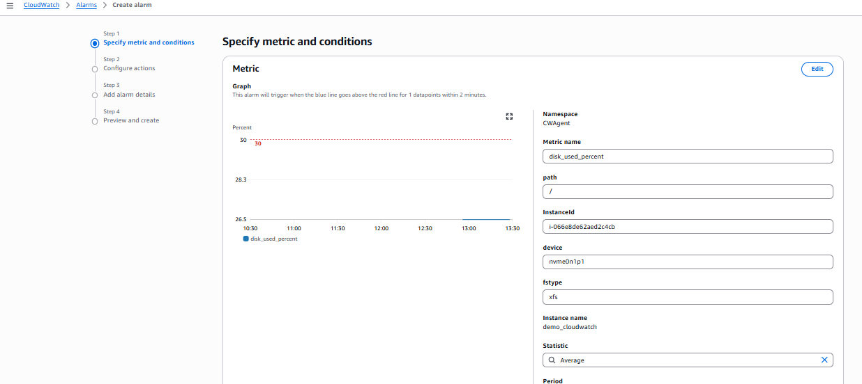
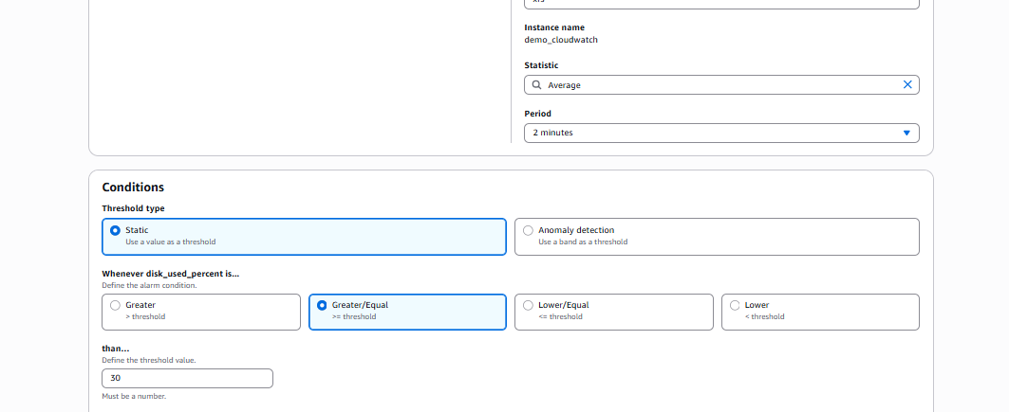
In configuration section need to add SNS topic so for this need to create SNS topic
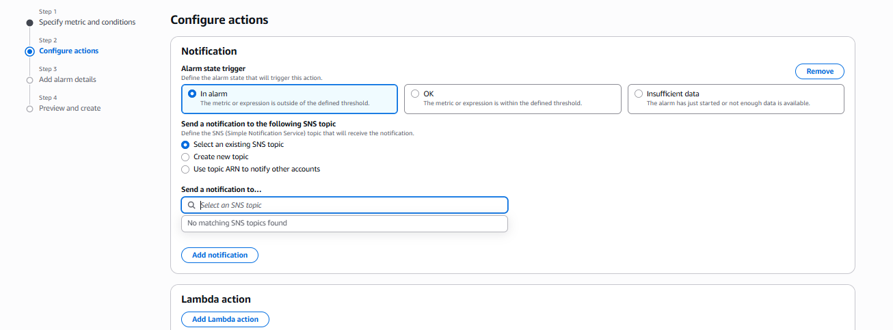
Need to create SNS topic as mention below

First create the SNS topic as mention below and then inside create the subscription
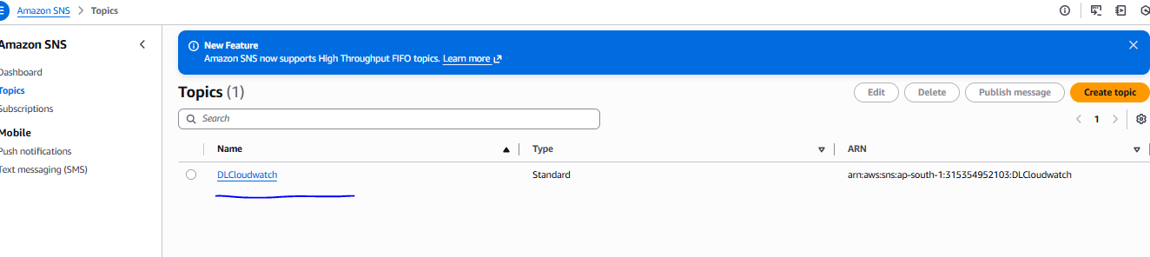
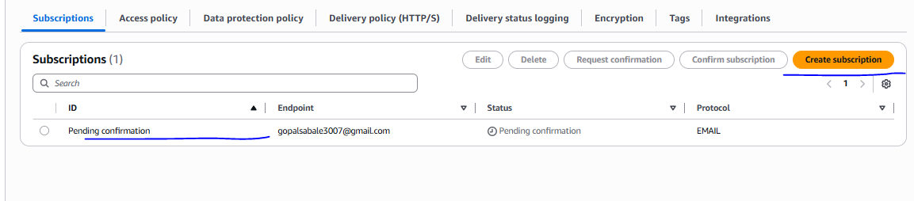
Once subscription confirm please from mail then showing status
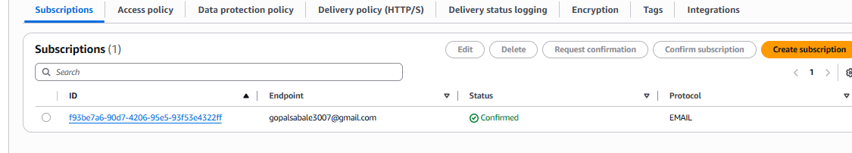
Once SNS topic has been created please add the SNS topic in alarm as mention below then click on next button

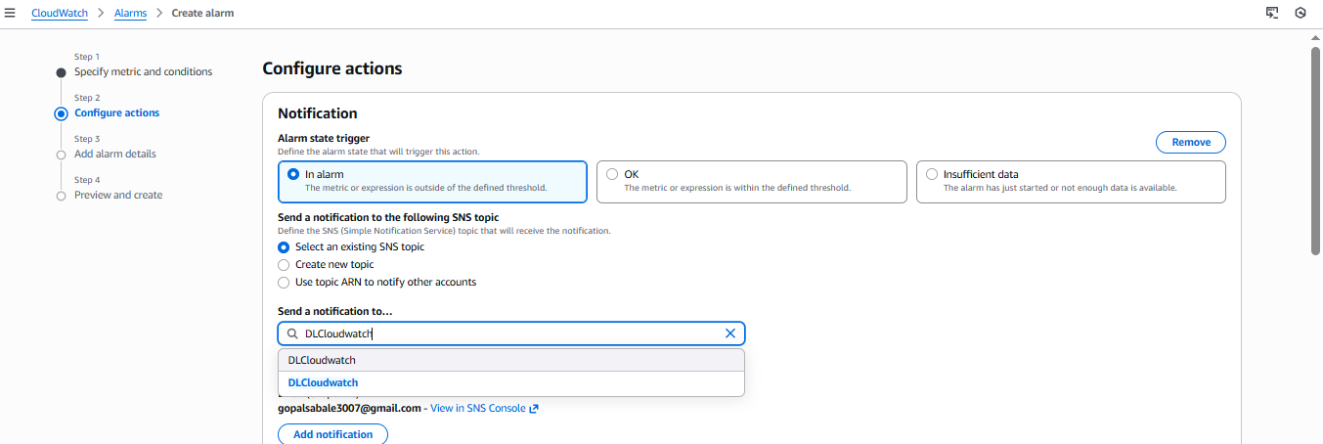

Then nominate the alarm then click on next button and create

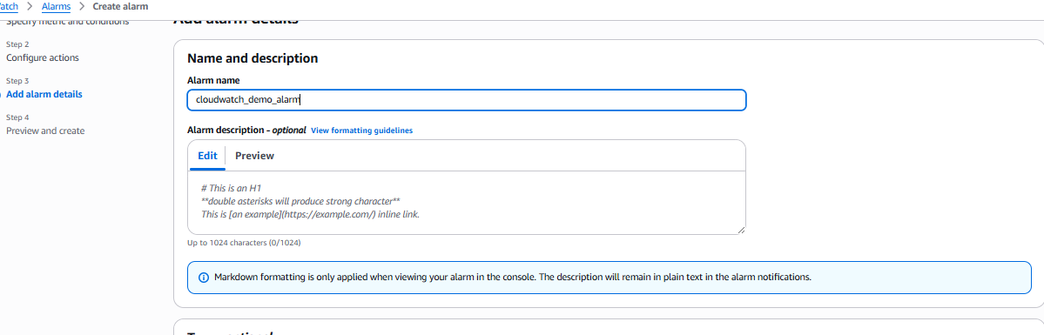
For verify need to download and extract high size file and on root path
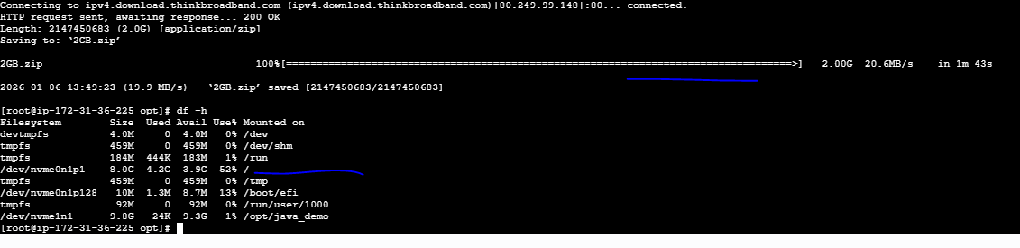
alarm has been received
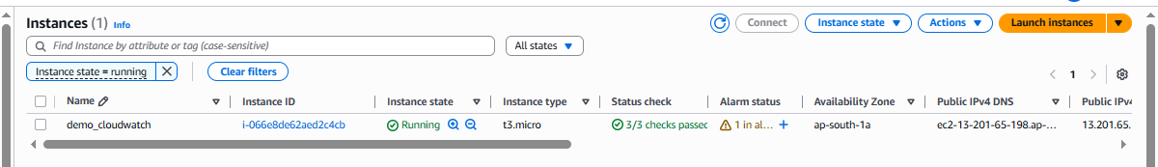
Cloud watch monitoring
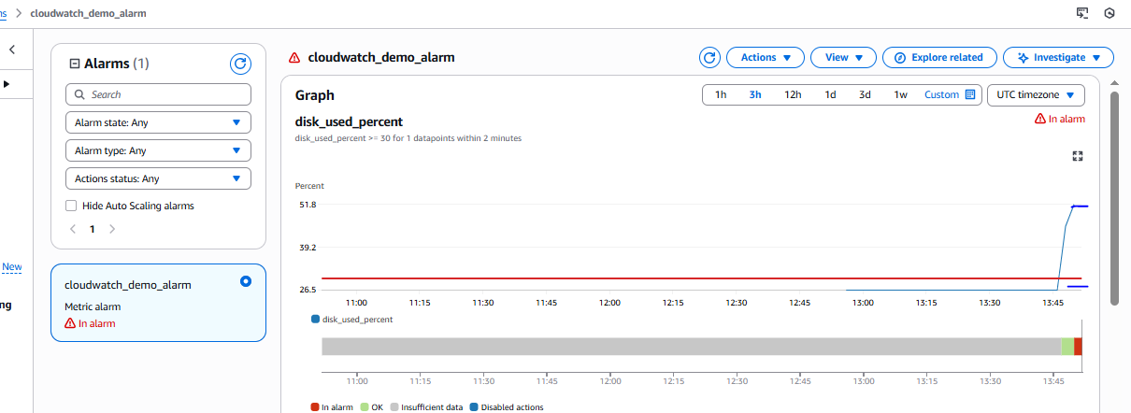
Alarm also received on subscription mail

